Ex.no:6 | DATA VISUALIZATION USING POWER BI

Aim:
To perform data analysis, data preparation, and advanced data visualization using Power BI on the Sleep Health and Lifestyle dataset, and to create interactive charts, cards, and slicers for analyzing sleep patterns, sleep quality, stress levels, physical activity, and sleep disorders.
Algorithm:
1. Importing Dataset
- Open Power BI Desktop.
- Select Home → Get Data → Excel/CSV.
- Select the Sleep Health and Lifestyle dataset and click Load.
2. Data Cleaning
- Select Home → Transform Data.
- Remove duplicates and handle missing values.
- Check data types and standardize categorical fields.
- Click Close & Apply.
3. Average Sleep Duration by Occupation
- Select Clustered Bar Chart.
- Add Occupation to Y-axis and Sleep Duration to X-axis.
- Set Sleep Duration to Average.
- Give the title Average Sleep Duration by Occupation.
4. Sleep Disorder Distribution
- Select Donut Chart.
- Add Sleep Disorder to Legend and Person ID to Values.
- Set Person ID to Count.
5. Quality of Sleep by BMI
- Select Clustered Column Chart.
- Add BMI Category to X-axis and Quality of Sleep to Y-axis.
- Set Quality of Sleep to Average.
6. Sleep and Activity Analysis
- Create a Line Chart using Age and Average Sleep Duration.
- Create a Scatter Chart using Physical Activity Level and Sleep Duration.
- Add suitable titles.
7. Dashboard Creation
- Create DAX measures for Average Sleep Duration, Quality, Stress, and Daily Steps.
- Add Card visuals and slicers for Gender, Occupation, and Sleep Disorder.
- Arrange the visuals to create an interactive Sleep Health and Lifestyle Dashboard and save the .pbix file.

Output
Clustered Bar Chart:
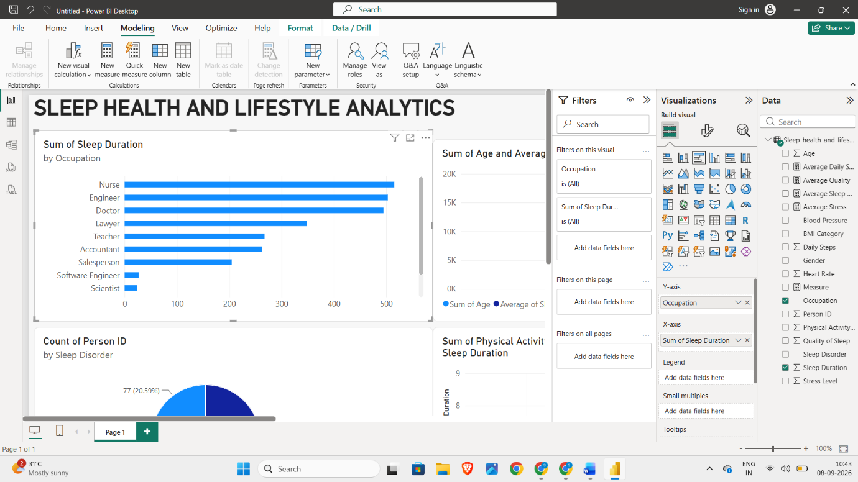

Donut Chart:
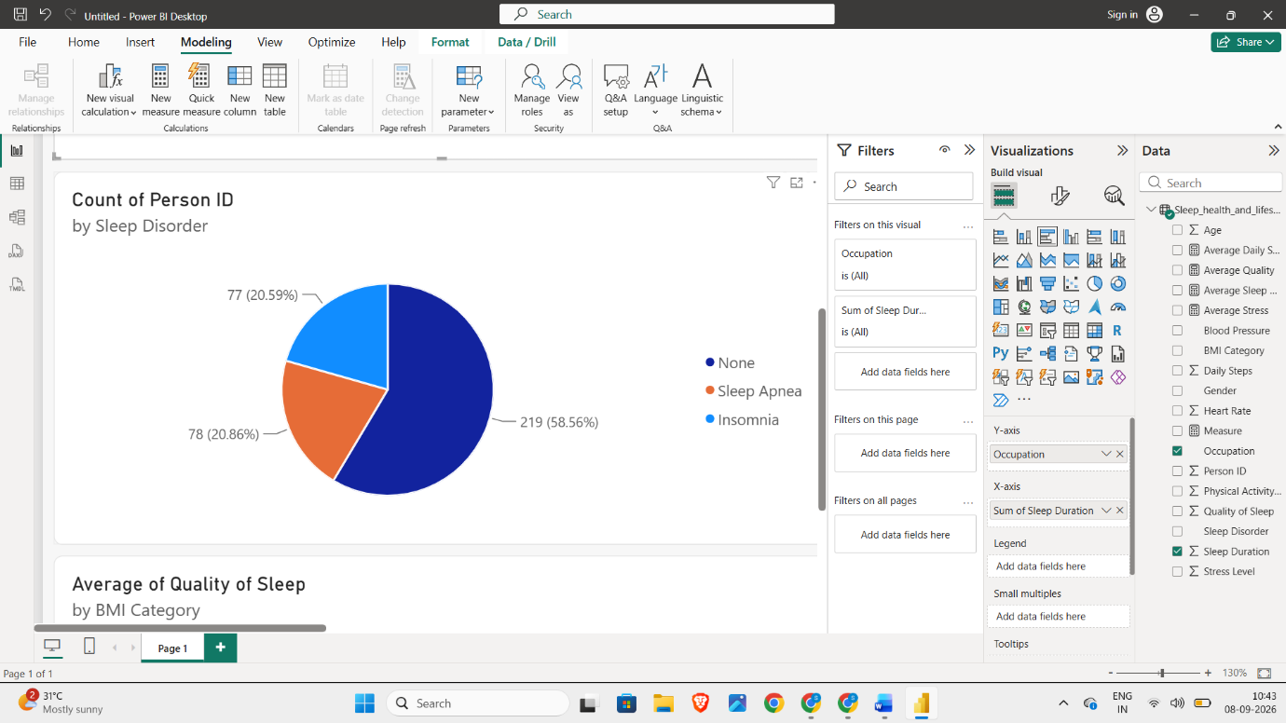
Clustered Column Chart:
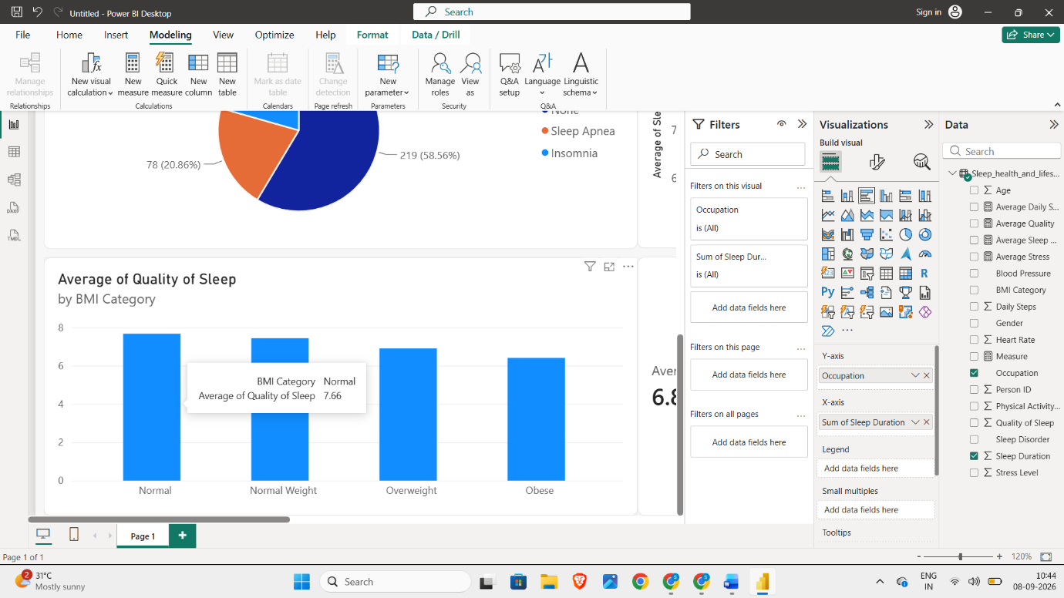

Line Chart:
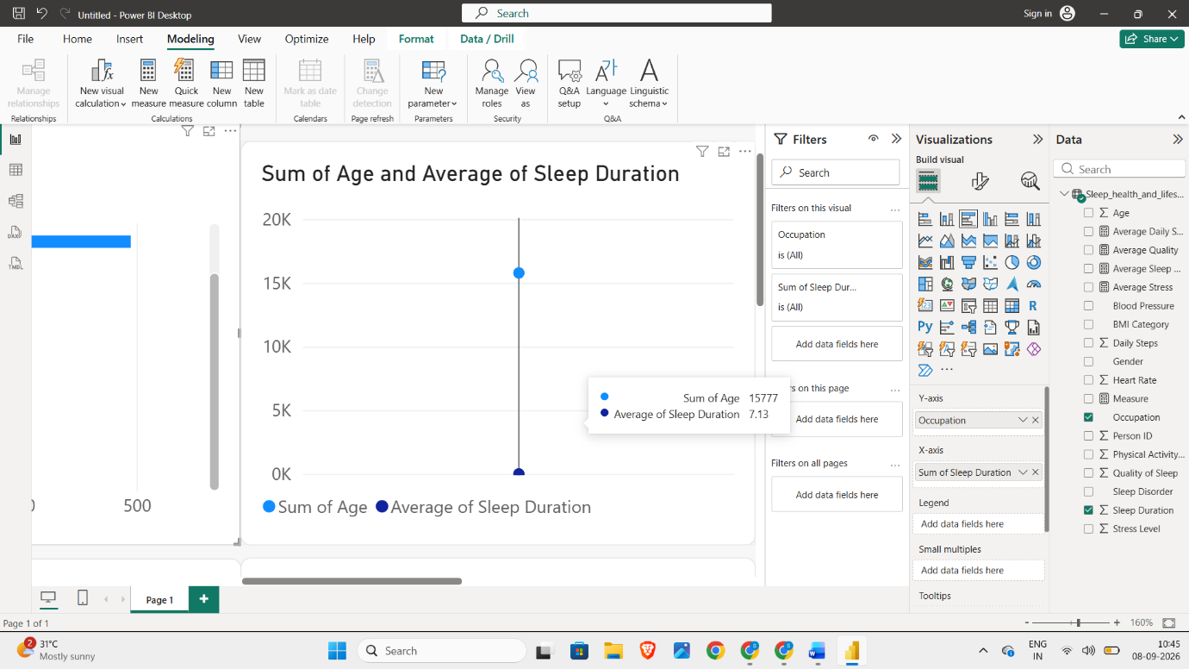
Scatter Chart:
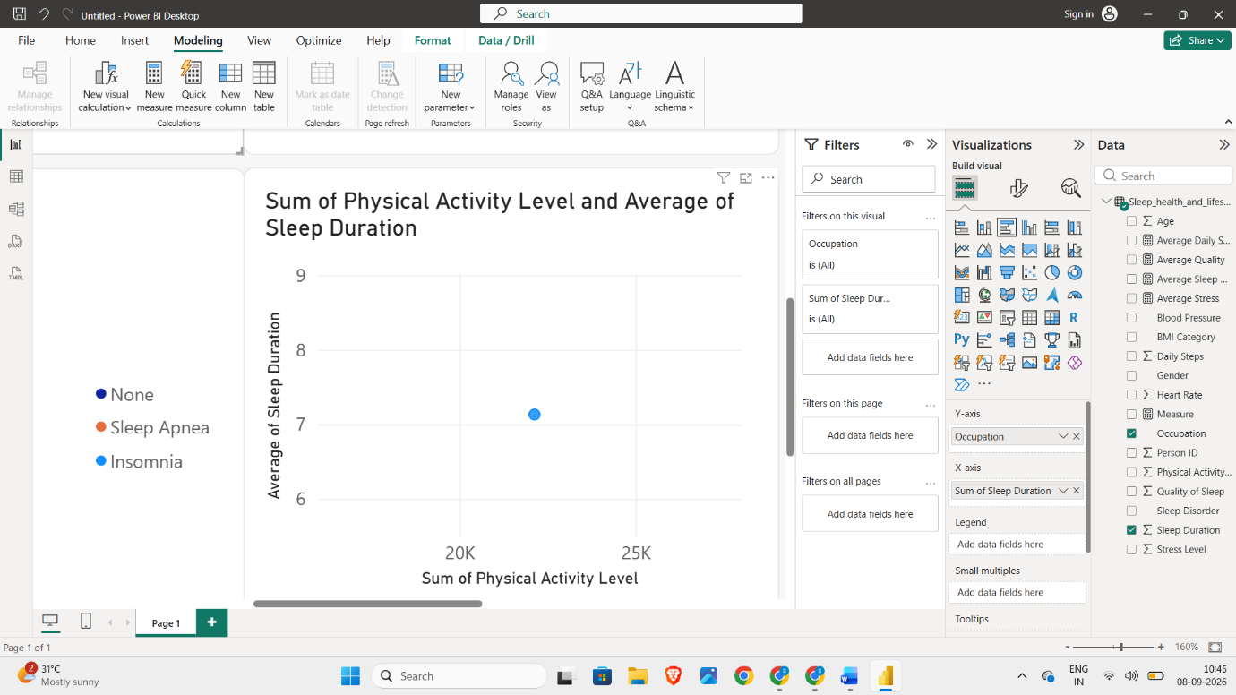

Dashboard Creation:
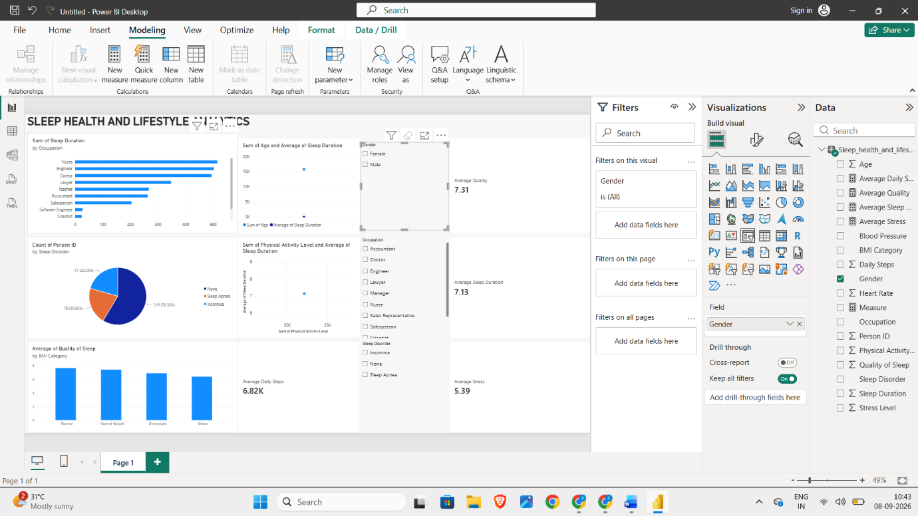

Result:

